Wolny Aleksander

DESCRIPTION:

I decided to find as many bugs in the exercises as possible. Concentrating only on the specific content of the task. All tests were carried out in a manual manner. Below is a list of errors I have found. Options that work and have been written in the content of the task have been omitted.

WEBPAGE WITH TASKS:

<https://buggy-testingcup.pgs-soft.com/task_1>

ENVIRONMENT:

* Windows 10
* Google Chrome 71.0.3578.80 (64-bitowa)

EXERCISE 1:

* 1. Should be the upper limit on the product to 100. Since you cannot add any more.



* 1. No possibility to reduce the number of products in the basket. For example, from 10 to 9. You can only delete the whole and add again, less.



* 1. There is no message like "do you really want to delete products". Protects against accidental deletion.
  2. The "Usuń" button could be in a different color, eg red. To indicate that it is used for deletion.



EXERCISE 2:

* 1. No possibility to return to all categories. When a category is selected.
  2. No Upper case support. Entering the phrase "sport" will not give a result such as entering "Sport".

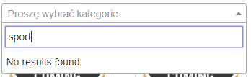 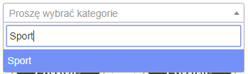

* 1. Mapping on Polish characters does not work. Entering the word "uslugi" does not suggest the word "usługi".

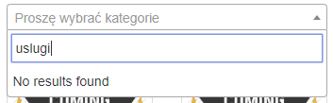 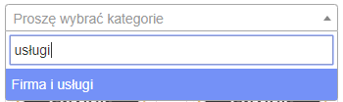

* 1. No possibility to filter the product. Typing the phrase "Piłka" does not suggest anything.

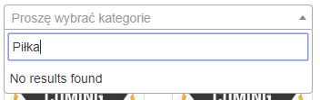

* 1. Cannot chose more categories at once.
  2. Cannot enter several different products at once. E.g. "Piłka, Buty, Aparat".

EXERCISE 3:

* 1. When the form is blocked, by hovering over the input fields, the mouse changes the cursor to the blocked one. This is not happening when hover over "Choose file" from the "Photo:" category.

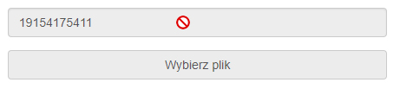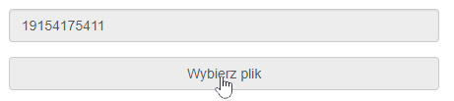

* 1. There is no restriction of characters entered in the name and surname tab. It is possible, to enter letters, numbers and special characters.

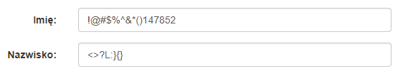

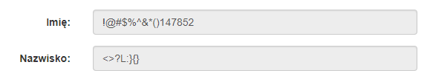

* 1. There is no restriction of characters entered in the Phone tab. It is possible, to enter special characters: % & ( ' +.



* 1. Possibility to save incorrect phone number



* 1. In the Telephone tab, the placeholder should suggest what the format of the phone number supposed to look like.
  2. There is no message about successful save.
  3. The image in the "TIFF" format does not appear.
  4. No information what file format and file size are supported.
  5. The "Zapisz do pliku" option in the Menu does not work.

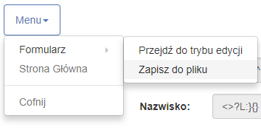

EXERCISE 4:

* 1. Lack of website responsiveness.

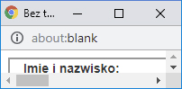

* 1. The new window has no page title.



* 1. The border around the form has a lot of empty space at the bottom.

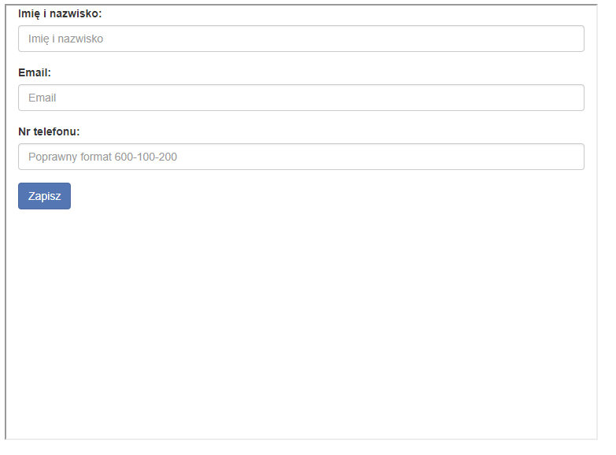

* 1. It is possible to enter any characters in each field.

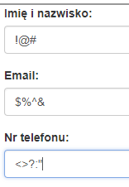

* 1. No information about the incorrectly entered format for any field.
  2. Phone number field has no limit on the number of characters entered. Doesn't have max limit.

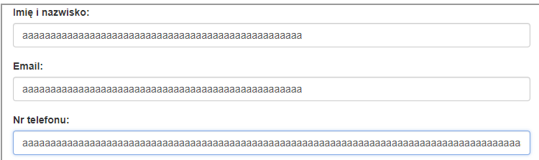

* 1. Button “Wyślij” should be renamed to “Zapisz”.



* 1. There is no information about the success of the performed action after pressing the "Zapisz" button.
  2. Placeholder email should tell, what the correct email format looks like.

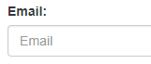

EXERCISE 5:

* 1. Button “Wgraj plik".” should be renamed to “Browse”.



* 1. Table should display 20 rows, but only shows 10.

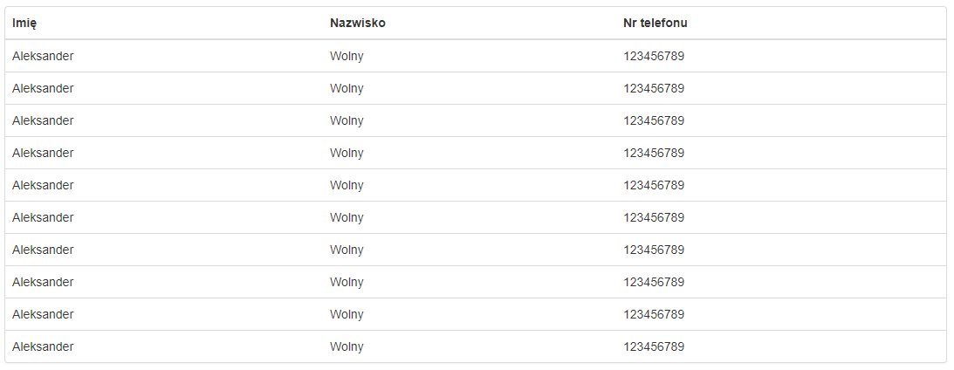

* 1. It is possible to enter no data in the first name and last name column.

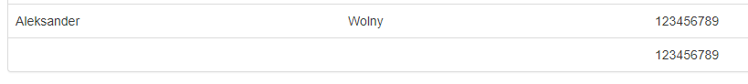

* 1. No character length restriction for name and surname.



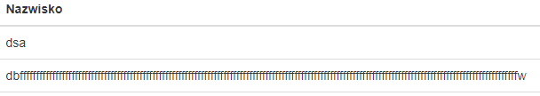

EXERCISE 6:

* 1. The "Pobierz plik" button does not work.

EXERCISE 7:

* 1. Drag & drop does not work. None of the products is added to the basket in this way.

EXERCISE 8:

* 1. No validation of the "Name and surname" field. It is possible, to enter letters, numbers and special characters, without max limit.



EXERCISE 9:

* 1. Folder is expanded by double clicking, on the folder name. The specification suggests one click.
  2. Changing the folder name, to some special characters causes, that the information about the folder is no longer displayed. Characters: blank character (space), „#", „%".

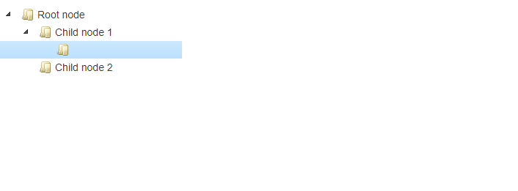

* 1. No information in the documentation - the ability to navigate through folders, using only the directional arrows on the keyboard.
  2. Some special characters are displayed in the HTML Entity format. For example, the character "<" is displayed as "& lt;".

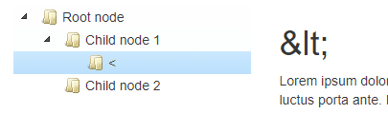

EXERCISE 10:

* 1. The js script does not work. The page is scrolled in a default way for a given browser.
  2. No "End" inscription at the bottom of the text.
  3. The text is not played. The whole works in a default way.

SUMMARY:

The website contains specially introduced errors in order to be able to test it with automatic tests. In this document, I focused on purely manual tests that might not appear in automated tests.